--1. Mailing Labels

select concat(contacttitle, ' ', contactname, char(13),

companyname, char(13),

address, char(13),

city, ' ', customers.Region,' ', postalcode,' ', country,

char(13),char(13))

from customers;

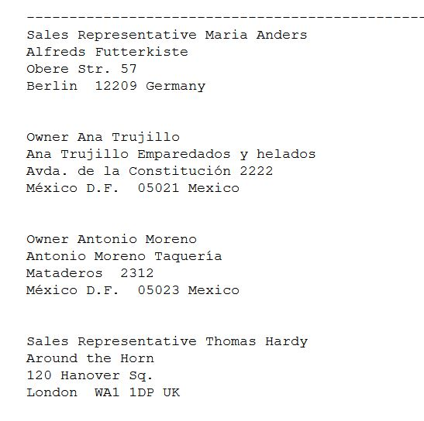

--2. Telephone Book: Lastname, Firstname Middlename [tab] Company name [tab] phone number*/

select substring(contactname, charindex(' ', ContactName)+ 1, len(contactname)) as LastName,

left([ContactName],charindex(' ',[ContactName] + ' ')-1) as First_Name, ' ' as Middle_Name,'', CompanyName, '',Phone

from customers;

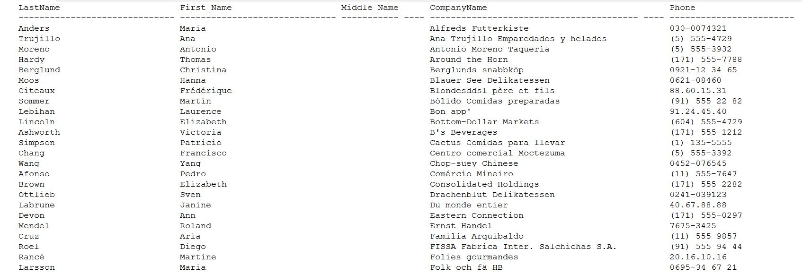

-- 3. Shipping Lag Report: the order number, the order date, the shipped date, and the diff_erence in days between the order date and the shipped date

select orderid, orderdate, shippeddate, DATEDIFF(day, orderdate, ShippedDate) as LagDays

from orders where DATEDIFF(day, orderdate, ShippedDate) > 0;

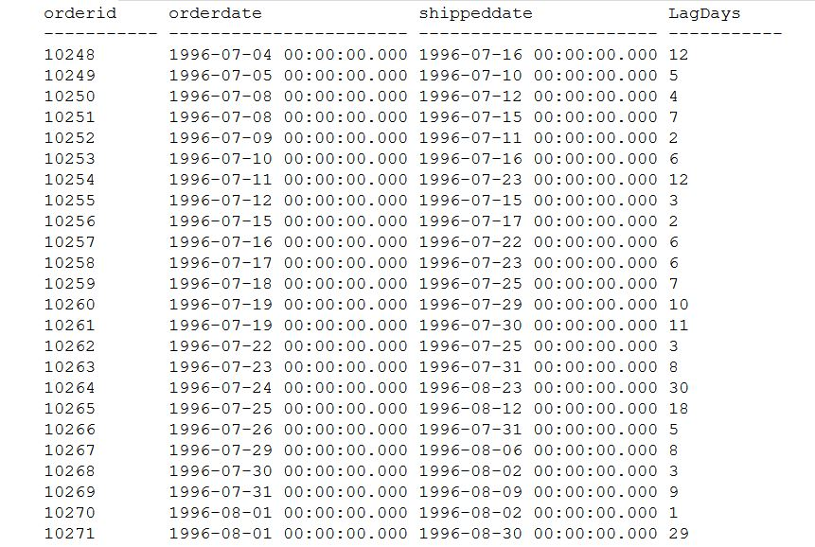

--4. Your Age in years, months, weeks, days. Assume 365 days/year

select DATEDIFF(YEAR,'19860814', '20200301') as Years, DATEDIFF(Month,'19860814', '20200301') as Months, DATEDIFF(DAY,'19860814', '20200301') as Days,

DATEDIFF_BIG(HOUR,'19860814', '20200301') as Hour, DATEDIFF_BIG(MINUTE,'19860814', '20200301') as Minutes, DATEDIFF_BIG(SECOND,'19860814', '20200301') as Seconds;

